PANELS

Keyboard

Keys that may not be available on a normal keyboard can be entered using the virtual keyboard. Should your keyboard be equipped with the required keys, you do not need to use the virtual keyboard. If the keyboard does not appear on your screen automatically, choose View > Keyboard to have it displayed.

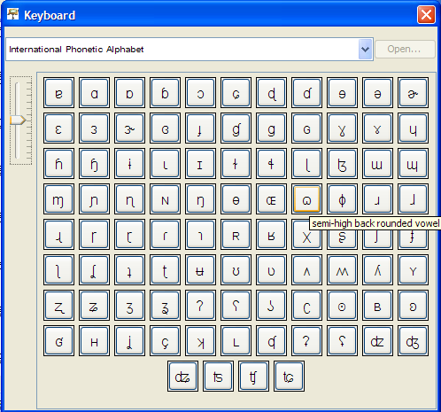

The scrollbar on the right hand side allows alterations in size of the keyboard symbols.
Most symbols are equipped with a short "tool tip" that elaborates on both meaning and function. Hover over the symbol to have the "tool tip" displayed:

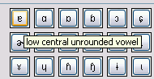

To insert a symbol into the musical score, move the cursor to that position in the musical score and click on the desired symbol. To choose a different keyboard, click on the arrow and select a different keyboard from the list. Please note:

A number of symbols are only available in a few fonts, namely those that cover a great range of Unicode (e.g. "Arial Unicode MS“). The font that is used in the keyboard can be selected in "Edit > Edit preferences". If the desired symbol appears as a square in the musical score, the tier's font needs to be reformatted. (see also "Format > Edit format table").

Link panel

The link panel links event descriptions to image, audio, video and text files. Should the link panel not appear on your screen, choose View > Link panel to have it displayed.

To link an event to an external file, select the event in the musical score and choose whether it's an image, audio, video or text file in the "Link Medium“ menu. Enter the storage location of the file to be linked in „Link URL“. Click Browse... to open a new dialogue. Here, you can search for the file on your computer.

The appearance of the upper part of the link panel depends on the type of media file chosen. An image will be shown in the upper half of the link panel. The same applies to a linked video file. When linking audio and video files, the panel will display an additional player for the playback of these files. The content of a linked text file will be display in a preview window.

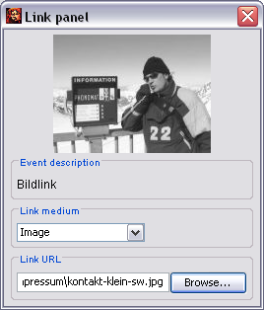

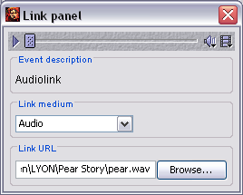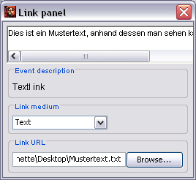

Audio/Video panel

The Audio/Video panel plays digitised recordings and assigns absolute time values of the recording to points on the EXMARaLDA time axis. When working with a single audio recording that does not need to be realigned or the like, it is not required to display the Audio/Video panel. If the Audio/Video panel does not appear on your screen automatically, choose View > Audio/ Video panel to have it displayed.

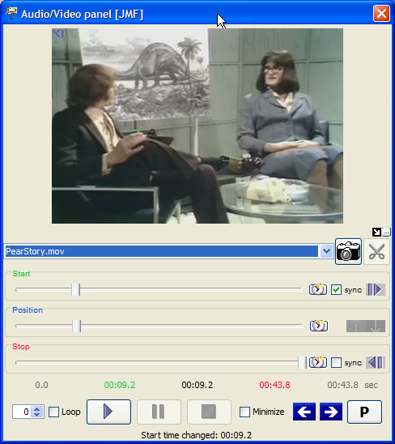

Depending on whether it is an audio or video file, the panel will be shown with or without a display. The controls are almost identical in both cases.

Controls:

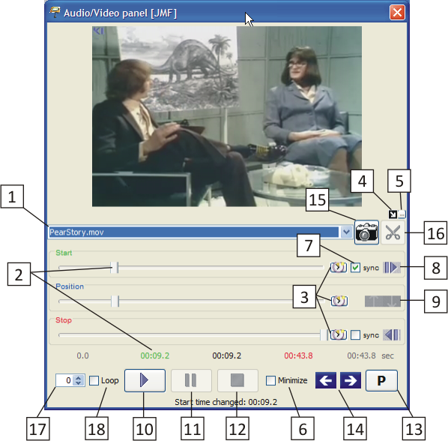Normally the Partitur-Editor will load the first audio/video file into the currently open transcription that has been marked as the "Referenced media file" in the meta information. Should you want to use a different audio/video file that is linked to the transcription, select it on the drop-down list 1 .

The size of the panel is adjustable. You can minimize the panel by clicking the control element 6 by hiding the slide bar (1). Should you open a video file, the panel will automatically be extended by a display. In addition, the button panel (2) can be hidden by clicking on the control element 5 . Under these conditions, the arrow key 4 allows you to choose whether the video should be displayed next to the panel, or above it.

(1)
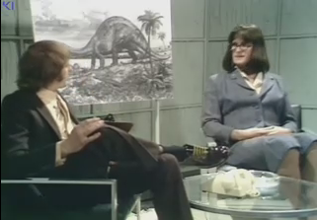
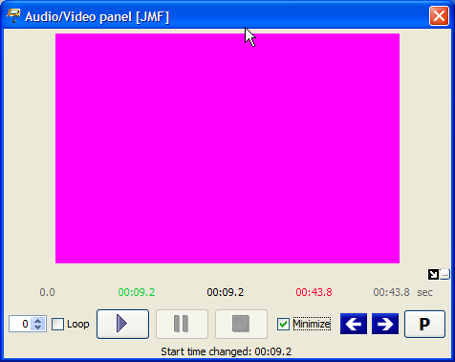

(2)
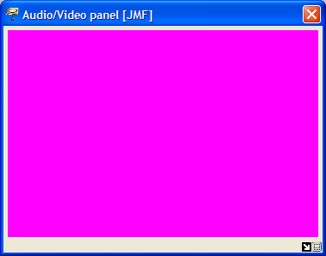

The three slide controls show the start and end position, as well as the current position in the audio/video file:
The "Start"slide control 2 defines at which position in the file playback should begin. The corresponding numerical value (seconds from beginning of file) is displayed in green below the slide controls. For fine tuning of the value, use the mouse. Left clicking on the green digits reduces the value by 0,1 seconds, right clicking increases it by 0,1 seconds.
The "Stop“ slide control defines at which position in the file playback should end. The corresponding numerical value (seconds from beginning of file) is displayed in red below the slide controls. For fine tuning of the value, use the mouse key. Left clicking on the red digits reduces the value by 0,1 seconds, right clicking increases it by 0,1 seconds.
During playback the "Position" slide control displays the current position in the file. The corresponding numerical value (seconds from beginning of file) is displayed in black in the number sequence below the slide controls.

For playback of a file, click the "Start“ button 10 = F1 button. If desired, it can be paused and continued with the "Pause“ button 11 = F2 or stopped with the "Stop“ button 12 = F3 If the Stop position or the end of the file is reached, playback will terminate automatically. If the "Loop" option 18 is activated, the current selection will be played in a loop.

There are multiple options to change the start and stop times of playback:
Using the "Start“ and "Stop“ slide control 2 and 3 or clicking on the coloured values.
Transferring the currently selected time values from the transcription: When clicking on button 8 the absolute time value of the current selection in the transcription in the editor will be determined and transferred to the "Start“ slide control. There is an equivalent button for the "Stop" slide control.
Synchronising the start and stop times with the transcription selection. If the sync options of the start or stop slide controls 7 are selected, the transfer of the currently selected time values in the transcription will automatically be used. Thus, the start and stop times will continuously be adjusted according to the transcription selection in the editor.
Transfer of a break duration: If the recording has been stopped with the "Pause“ button, the current position can be transferred to the"Start“ or "Stop“ slide control with button 9 .

The current values of the "Start“, "Stop“ and "Pause“ slide controls can be transferred to a marked time point (i.e. from the recording into the transcription) with button 3 . If no time point is marked on the time axis of the transcriptions, these buttons will be deactivated.

The two arrow keys 14 allow a direct access from the Audio/Video panel to the cursor position in the musical score. By clicking, the cursor can be moved to an event further to the right or to the left.

Depending on whether an audio or video file has been opened, the control element 15 or the control element 16 will be activated.

The "camera" 15 allows you to generate single frames from the imported video file in the transcription in a png format. In order to do this, move the"Start“ slide control 2 to the desired position of the video and click on the "camera“. A pop-up window will then ask you to choose a storage location for the image file.

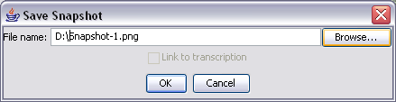

Should you want to select a different storage location than the one that the program automatically generated, click Browse… . Please not that the file ending ".png“ may not be changed.

If you have added a tier for links in your transcription and placed the cursor into the tier of this event, the panel will offer the option to link the event to the newly generated "Snapshot". Click on „Link to transcription“. A detailed description on linking files can be found in the functional reference under "VI. Panels > B. Link panel".

The "scissors“ 16 allow you to create "audio snippets" in the wav format in a synchronised transcription linked to an audio file. Position the cursor into the transcription in the event for which you would like to create an audio snippet and click on the "scissors". A pop-up window will then ask you to choose a name and a storage location for the audio file.

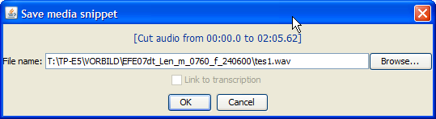

Should you want to select a different storage location than the one that the program automatically generated, click Browse… . Please not that the file ending ".mov“ may not be changed.

If you've added a tier for links in your transcription and placed the cursor into the tier of this event, the panel will offer the option to link the event to the newly generated "Audio snippet". Click on "Link to transcription". A detailed description into linking files can be found in the functional reference under "Panels > Link panel".

Please note that the embedding of media files will not always run smoothly. A successful linking depends on:
- the file format of the video (we recommend .avi or .mov),
- the performance features of the video card of your computer, and
- the Codec settings.

Should you encounter problems, please consult the document Audio and Video Support in EXMARaLDA.

Praat panel

The Praat panel plays digitised recordings and assigns absolute time values of the recording to points on the EXMARaLDA time axis. Should the Praat panel not appear on your screen, select View > Praat panel to have it displayed.

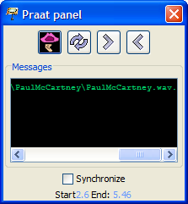

Configuration of Windows and Praat for working with EXMARaLDA

The current version of Praat can be found on http://www.praat.org.There, the current version of Sendpraat is available as well, on http://www.fon.hum.uva.nl/praat/sendpraat.html.
Download both programs and save them in the same directory (e.g. c:\Programs\Praat). Then create the path

1)by either selecting "Edit > Preferences" in the tab "Paths" under "Praat Directory" and entering the directory of praat.exe and sendpraat.exe. (This option is available since version 1.4.3.)

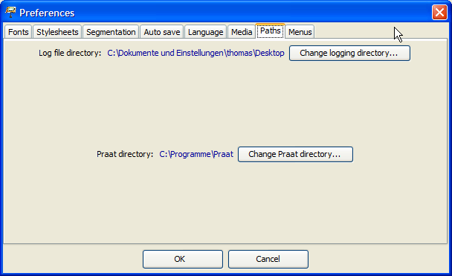

2) or by setting up the system path so that it contains the directory: Go to the Control Panel (e.g. in MS Windows XP Start > Control Panel> System > Advanced > Environment Variable)

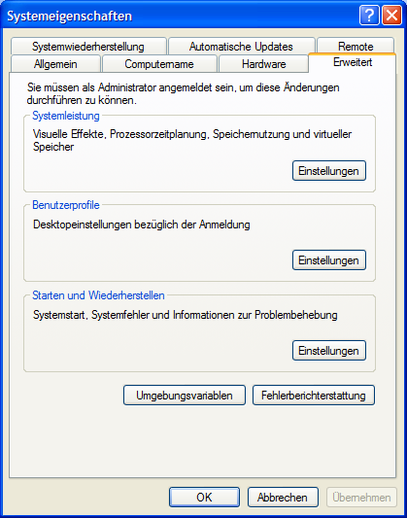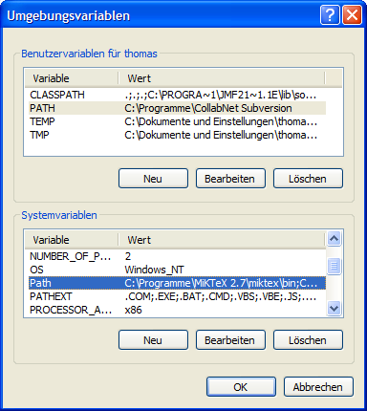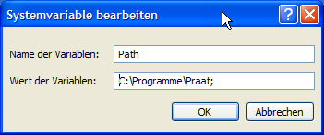

Please note: The Praat panel is currently only available in MS Windows. The use of the Praat panel requires the installation of the programs Praat and Sendpraat on your computer and the system path pointing to the directory in which these programs are located.

If you have completed this set up, you can start the program Praat directly in the Partitur-Editor by selecting Start Praat. This will take a few seconds. Wait, until the program has started completely and then confirm the "Starting Praat..." dialogue that will be displayed in the Partitur-Editor with OK.

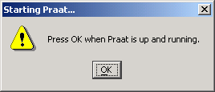

If the meta information of currently loaded transcription in the Partitur-Editor holds an audio file as a "Referenced File", the Praat panel will automatically insert it as a file that should be loaded in Praat.

The actual loading process of the file can be done by selecting (Re)load. Praat will now open a "Long Sound" window that will display an oscillogram and possibly further visualisations of the audio file.

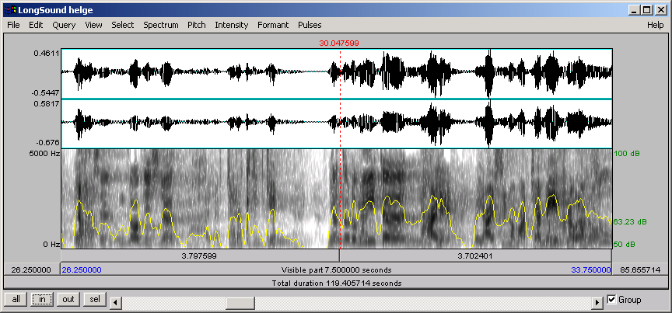

Rearrange this window on the screen so that the musical score, the Praat panel and "Long Sound" window are simultaneously accessible. To determine the audio file snippet shown in Praat, choose one of the following two options:

- Choose a section of the transcription in the Partitur-Editor and then choose > Set. in the Praat panel. The section's absolute time values of the transcription's time axis will be used as the start and end values of the section displayed in Praat.
- Activate the option Synchronize with selection in the Praat panel. The selection in the Partitur-Editor will automatically be synchronised with the displayed section of the audio file in Praat.

While > Set transmits time values from the Partitur-Editor to Praat , <Get transmits this communication the other way around. For this, mark a point on the time line in the Partitur-Editor and click < Get. The absolute time value at which the cursor in Praat (the red line in the image above) is now will be attached to the selected time point (see also Appendix E).

Annotation Panel

The Annotation Panel allows the systematic and consistent adding of annotations to a transcription. The way it functions is comparable to the functionality of the virtual keyboard. It consist of a compilation of symbols that can be added into the musical score by clicking on them. Firstly, however, the annotation panel allows these symbols to be organised hierarchically (i.e. in a tree structure). Secondly, the user can define categories for the annotation panel freely (see How to use and configure the annotation panel). Third, the annotation panel can "intelligently" adapt itself to the annotation task by hiding certain category sets in the hierarchy depending on the current selection in the musical score.

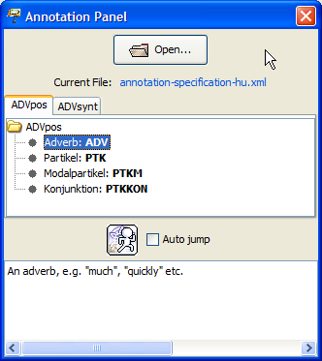

Show the annotation panel via "View > Annotation Panel". If available, the last annotation specification will be loaded automatically. To load a new specification, click "Open..." and select the XML file in which the annotation specifications are defined.
An annotation specification consists of one or more annotation sets. In the annotation panel,an individual tab is opened for every annotation set. Every annotation set consist of categories within categories that are presented in the form of a tree. Categories can be equipped with a day and a description, however, this is not a requirement. Tags are displayed in bold in the tree, descriptions of the selected category are displayed in the text window below the tree. Double clicking on a category with a tag adds the tag to the current cursor position in the musical score.

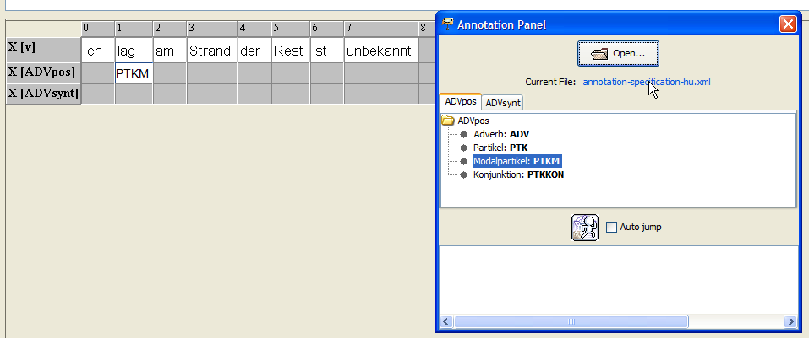

IPA Panel

The IPA-Panel supplies the symbols of the International Phonetic Alphabet. The symbols are organised by parameters, such as manner or place of articulation. The Panel consists of three tabs:

Vowels and Suprasegmentals:

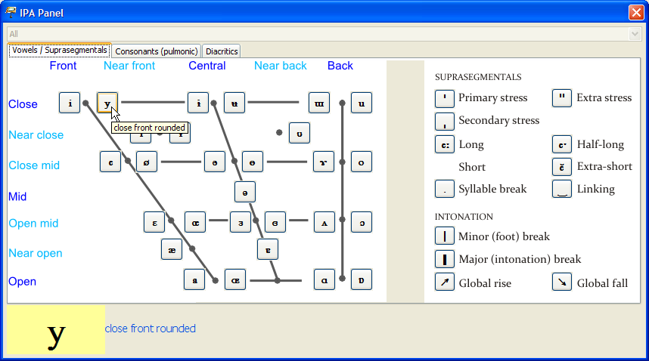

Consonants:

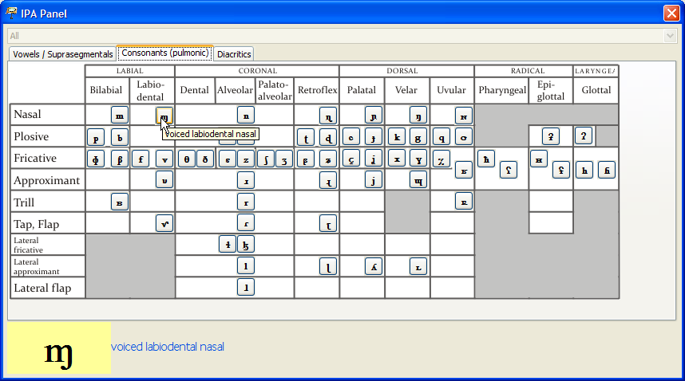
Diacritics:

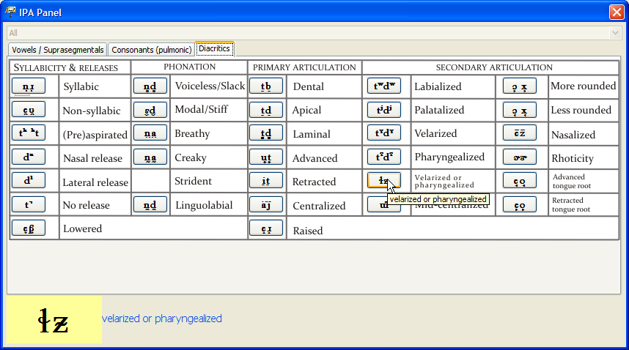

A larger version of the symbol will be displayed in the lower part of the panel, when hovering over the symbol with the cursor. Clicking on the symbol adds it to the current cursor position in the musical score.

